This topic describes the application requirements for caAERS, how to log in, and the caAERS opening window (or dashboard). Suite users may see an additional Comments/Alerts tab which is described. A table lists each caAERS component and the appropriate topic links. There is also general information about searching for and finding results in caAERS.

Application Requirements
The caBIG Adverse Event Reporting System (caAERS) application is an open source, standards-compliant application. It is web-based and enables multiple users to access, search for, and report on Adverse Events (AE), both in-house and to external agencies. To access and use caAERS, your computer must meet the following requirements:
- Internet connection: speed of 56K or faster (broadband) recommended
- Browser: Firefox 2.0 or higher; Internet Explorer 6.0 or higher (IE 7 recommended)
- Display: resolution of 1024 x 768 or better is recommended, 800 x 600 is supported

Logging In

Logging into to a Standalone Version of caAERS
To log into caAERS, navigate your web browser to the caAERS website. An administrator must provide you with login details, including your user name, password, and the URL to caAERS.
For standalone users, you will log into the caAERS login page.
- Enter your Username.
- Enter your Password.
  - If you forget your password, click forgot password and follow the prompts.
- The caAERS dashboard opens.
Note: While caAERS will log you out after some pre-set amount of time, you should always logout manually to insure that others do not access the system using your credentials.

Launching the caBIG Clinial Trials Suite
For caBIG Clinical Trials Suite users, you will log in at the Suite single sign-on page. This enables you to log in only once and have access to all Suite products installed on your system. To launch the suite, see Launching the Suite.
Note: To exit The Suite, you must log out of each application or close each window individually.

caAERS Dashboard
Once you log into caAERS, the top of the dashboard displays your log in username and the Logout button. If you need help or more information about an open page, click Help to access documentation.
The dashboard uses three levels of access to use the caAERS components
- The navigation menu accesses caAERS components, for example, the Subjects tab.
- The task menu lists the tasks you can perform under a tab, for example, you can Enter Subject.
- The steps menu lists the numbered steps to follow for a task, for example, there are multiple pages to fill in when you enter a subject.
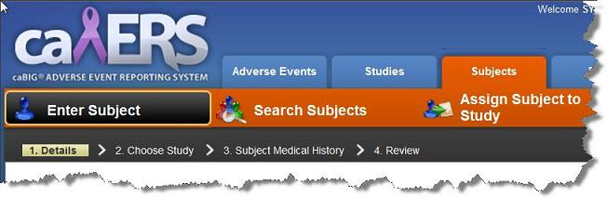
Although you can access any caAERS function through the navigation menu, the Welcome page also lists caAERS functions under headings like Adverse Events, Report Definitions, and Reporting Rules, and Administrator. Once you become familiar with caAERS, these lists will enable you to access what you need quickly.

Comments/Alerts Tab - caBIG Clinical Trials Suite Users Only
Once caAERS is installed, you may see a Comments/Alerts tab on the right side of the dashboard when you perform certain tasks. This tab alerts caAERS users when an out-of-range lab may need to be reviewed and added to caAERS as an adverse event.
- All the out of range labs for a patient, including those not related to the study, are electronically graded, and once validated are sent as an alert from caBIG Lab Viewer to caAERS via the Comments/Alerts tab. You can access caBIG Lab Viewer within caAERS to view and load the out of range labs into caAERS. For more information, see Linking to Lab Viewer.
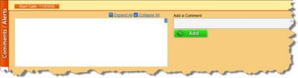

What You Can Do with caAERS
There are six main components or tabs on the caAERS dashboard.
Note: Based on the role that you are assigned in caAERS or the way that caAERS is configured, you may not have access to all of the functions listed below.
Tab | Topics
Adverse Events | - Reporting Adverse Events instructs how to report a subject's adverse events that occur within a study during a course cycle. If expedited reports are required, this topic also instructs you how to enter all the expedited report information.  - Managing Adverse Event Reports instructs you how to manage the adverse event reports generated for a study/subject/course cycle.  - Routing and Review
Studies | Managing Studies instructs how to enter detailed information about about a study.
Subjects | Managing Subjects instructs how to add subject details to caAERS and assign subjects to a Study.
Rules | - Managing Rules instructs how to define rules for adverse events that will be used to generate user-defined reports for sponsors or other organizations (CTEP and DCP rule sets are provided with caAERS and generate expedited reports without additional rules).  - Creating and Managing User-Defined Reports instructs how to develop reports that will be generated when adverse events are entered that filfill certain user-defined rules.
Administration | - Configuring caAERS Options.  - Importing and Exporting Files instructs how to import files into caAERS to minimize data entry and export files from caAERS for import into another instance of caAERS.  - Managing Organizations instructs how to add, edit, and delete organizations (sponsors, institutions) so users can have access.  - Managing Research Staff instructs how to add, edit, and delete, users in caAERS.  - Managing Investigators instructs how to add, edit, and delete Investigators.  - Managing Investigational New Drugs instructions how to add, edit, and delete INDs into caAERS.
Advanced Search | - Performing Advanced Searches instructs how to create advanced searches with multiple search criteria and export the search results.

Searching in caAERS
Many caAERS pages perform similar functions, such as searching for items. These are some ways where caAERS makes searching easier:
Note: Any field on a screen with a red asterisk next to it (*) is required. You cannot save and continue to the next step, if you do not complete the required fields.
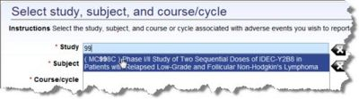
- Auto-complete fields These fields have blue boxes, and you can enter an item name completely or enter only a portion of the name or identifier. A list of possible matches pops up when you start to type, and you can select an item from the list. For example, if you type MC in a field with auto-complete enabled, the popup list shows any titles with MC at the beginning, middle, or end of the title.
- Display all results To display all of the search results, you can leave a field blank. If the field requires an entry, search for % (the percent sign) to display all results.

Finding a Search Result
Once a search is complete, the results display below the search fields.
To find a result in the list
- Navigate the search results
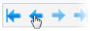
  - Page forward and backward
  - Skip to the beginning and end of the list
  - Indicate how many rows to display on one page, 15, 50 or 100 rows.
- Sort the search results
  - To sort the results by a column, hover over the column name. If a pointer appears, click the column name to sort the results. Note the triangle indicates whether to sort in ascending or descending order. To change the sort order, click the column name again.
- Filter the search results to narrow down the results
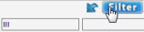
  - To filter the search results, enter values above the column names to limit the results to items containing those values. Click Filter. The filtered results are displayed.
  - To clear the filters, click Clear.

